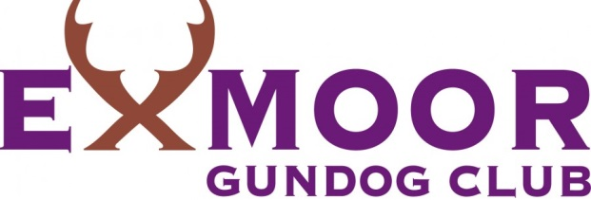

General Data Protection Statement

Exmoor Gundog Club is aware of the importance of data protection and, as a Club, we undertake to store safely your personal information.
Who is collecting the data?
Exmoor Gundog Club.

What data is being collected?
Personal data relating to Members, Judges, Competitors and Land Owners. This includes: Name
Address
Email Address
Telephone Number(s)

Why do we process the data ?
We process data for administration of the Club, communication with Members regarding events and activities, with Judges for communication regarding Judging appointments and with Competitors for entry into GWTs and FTs.

How long will the data be stored ?
As long as is necessary for the reasons we process the data.

Accuracy of data
Data is received from Members, Judges, Competitors and Land Owners. It is the responsibility of these persons to inform the Club of any changes in personal details.

Will the data be shared with any third parties ?
Data will not be shared with any third party with the exception of the Kennel Club.

Data Subject rights
Any individual has the right to see their personal information stored by the Club. A request should be made by letter or email to the Membership Secretary.

